A **Deterministic Finite Automaton (DFA)** is a formal model of computation used in automata theory to represent and recognize patterns within input data, particularly strings. It is called *deterministic* because, for each state and input symbol, there is exactly one state to transition to.

**Formal Definition of DFA:**

A DFA is typically represented as a 5-tuple:

⟨Q,Σ,δ,q0,F⟩

Where:

* Q is the set of states.
* Σ is the alphabet of input symbols.
* δ the transition function (δ:Q×Σ→Q)
* q0q_0q0​ is the initial state.
* FFF is the set of accept states.

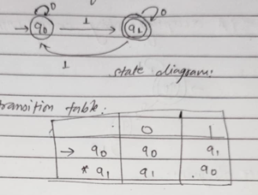

A **Turing Machine** is a theoretical model of computation used to define what can be computed. It consists of:

1. **Tape**
2. **Head**
3. **States**
4. **Transition Function**

A Turing machine is typically represented as a 7-tuple:

M=⟨Q,Σ,Γ,δ,q0,qaccept,qreject⟩

Where:

* QQQ is the set of states.
* Σ is the input alphabet (not including the blank symbol).
* Γ is the tape alphabet (including the blank symbol).
* δ is the transition function (δ:Q×Γ→Q×Γ×{L,R}
* q0q_0q0​ is the start state.
* Q accept the accepting state.
* Q reject is the rejecting state.

